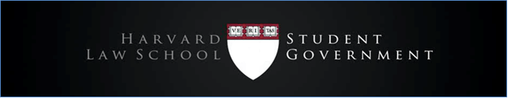

MEETING AGENDA
Nov. 1, 2017
HLS Student Government
Student Council

- Upcoming Activities & Events
  - Mental Health
    - Survey with HUHS (Tentatively set for 11/6-11/17)
    - Have we talked to other schools to create uniformity
      - Messaging based on Yale’s report from several years ago, but haven’t reached out to authors of the report
      - There will be uniformity across the Harvard schools
      - We are in contact with leaders of other T14 schools, so can try to promote a similar effort more broadly
  - Diversity & Inclusion
    - Staff appreciation exhibit: 11/6 until Thanksgiving Break
      - Thinking of making it interactive so people can make comments
        - Would be nice if we could do this
    - First generation working group
      - Will meet with deans and walk them through experience of being a first generation student
      - Profile of how student body is changing and how to address needs
      - Focus on first generation college students, not just law students
  - HLS Talks – Inaugural Event
    - Wednesday, 11/15
  - Community Service & Events
    - Thanksgiving: Thursday, 11/16 from 6pm-10pm
      - Ticket sales will begin on Monday
      - Will loop everyone in to help with fundraising and tabling
      - Ticket sales and raffle tickets will go to Y2Y
      - Scales of Justice will perform
- Sticker Incident
  - In addressing what happened, important not to give voice or feed into the message
  - Space for discussion in Milstein East at 8pm

