Board of Student Advisers
Harvard Law School

Wasserstein Hall 2051 (617) 495-4535
1585 Massachusetts Avenue Fax (617) 496-1084
Cambridge, MA 02138

Dear Applicant:

Thank you for your interest in the Board of Student Advisers. Originally founded by the Harvard Law School faculty to provide tutors for the moot court program, the BSA has served Harvard Law School for over 100 years.

During the 2023-2024 academic year, Board members will have a wide variety of duties. Beginning in August, BSAs will assist with the 1L Orientation program. BSAs will serve as Teaching Assistants for the First-Year Legal Research and Writing Program. Board members will also serve as general mentors and advisers for students new to the HLS experience, including 12–14 first-year students. In addition, BSAs will administer the upper-level and first-year Ames Moot Court competitions (though note that BSAs are allowed and encouraged to participate in the Ames competition, if they are interested). Finally, each BSA will contribute to the Board by serving on at least one internal BSA Committee, which offers exciting opportunities for BSAs to become involved in an area that interests them. For these duties, Board members last year received a stipend of $9,000-$10,000. Compensation for this upcoming year will be contingent upon the Harvard Graduate Student Union’s contract with Harvard University. BSAs also have the opportunity to receive academic credits for writing new LRW exercises.

The BSA believes that it can better serve students if it is fully representative of the student body. Therefore, the Board encourages students of all backgrounds to apply. The BSA provides equal opportunity in employment for all persons and prohibits discrimination in employment on the basis of race, color, religion, creed, sex, sexual orientation, gender identity, national origin, ancestry, age, veteran status, disability unrelated to job requirements, genetic information, military service, or other protected status.

The application is meant to provide a sense of each applicant’s personality and strengths, and therefore consists of multiple components, which are listed on the third page of this document. After completing the registration form, applicants to the BSA are asked to submit their resumes and application statements electronically on March 19, 2023 by 11:59 pm. Applicants will then participate in two interviews with current members of the Board, each of which will include a mock student conference based on the Mock Student Work Assignment, as well as a traditional interview. Additionally, applicants to the Board will be asked to provide their transcripts to Susannah Barton Tobin, Director of the LRW Program. Climenko Fellows will also provide a recommendation for each applicant to Ms. Tobin (but there is no need for applicants to request this recommendation). There is no grade threshold for applicants. Rather, the application is holistic, and academic transcripts and recommendations are just two of the pieces that will help provide a complete understanding of each applicant.

The BSA will notify applicants whether they have been accepted by the end of July 2023. If offered a role as a BSA for the 2023-24 school year, BSAs will be required to attend 1L Orientation in the fall. Please note that you cannot serve on the BSA if you do not attend Orientation.

We appreciate your interest and look forward to reading your application.

Sincerely,

The BSA Selections Committee

Sofia Panarella, Co-Chair spanarella@jd23.law.harvard.edu
Ronan Clague, Co-Chair rclague@jd23.law.harvard.edu
Bolatito Adetula badetula@jd24.law.harvard.edu
Debbie Park dpark@jd24.law.harvard.edu
Nicholas Gonzalez ngonzalez@jd24.law.harvard.edu
Vanessa Agudelo vagudelo@jd24.law.harvard.edu

Application Components

- Registration Form: Complete Now

If you have not yet completed the online registration form, follow the link above to do so. We will use the registration list to communicate with you throughout the application process.

- Resume, Statement of Interest, Optional Statement, and Interest and Extracurricular Activities List: Due Sunday, March 19, 2023, 11:59 PM

Your Resume, Statement of Interest, Optional Statement, and Interest and Extracurricular Activities List should be combined into a single PDF document and submitted as an attachment in a joint email to spanarella@jd23.law.harvard.edu and rclague@jd23.law.harvard.edu.

Please adhere strictly to the naming conventions below so that our filters function correctly:

File Name: LastName FirstName BSA Application 2023.pdf
(e.g., Lauber Vanessa BSA Application 2023.pdf).

Email Subject: LastName FirstName BSA Application 2023
(e.g., Lauber Vanessa BSA Application 2023).

Prompts for the Statement of Interest, Optional Statement, and Interest and Extracurricular Activities List are attached.

- Transcript Request: Due Sunday, March 19, 2023, 11:59 PM

Instructions for requesting a transcript are attached to this application.

The Director of the First-Year Legal Research & Writing Program, Susannah Barton Tobin, will be the only person to see your transcript.

- Mock Student Work Assignment: Complete and Bring to Your Interviews

The Mock Student Work Assignment, which includes two student outlines and a Bluebook feedback exercise, can be downloaded from the BSA Website at https://orgs.law.harvard.edu/bsa/apply-to-the-bsa/.

The Mock Student Work Assignment must be completed independently.

NAME OF APPLICANT:
HARVARD ID#:
Statement of Interest

Introduce yourself! The Board of Student Advisers relies on active and thoughtful engagement from each of its members. Please tell us a little bit about who you are and why you want to be a member of the Board.

Please limit your statement to 500 words. Your statement can discuss several discrete aspects of your background and does not need to be tied together in a cohesive essay.

NAME OF APPLICANT:
HARVARD ID#:
Optional Statement

The Board of Student Advisers makes every effort to understand you in the context of your background and to build a diverse board. If applicable, you may choose to submit an optional statement to elaborate on how you could contribute to the diversity of the BSA community.

Please limit your optional statement to 300 words.

NAME OF APPLICANT:
HARVARD ID#:

Interests & Extracurricular Activities List

What do you like to do? We are interested in hearing about extracurricular activities both at the law school and outside of it, personal hobbies, and other ways you spend the time when you are not in class.

Please answer in list form.

NAME OF APPLICANT:
HARVARD ID#:

Transcript Request Via Online Ordering System

Request a transcript before March 19, 2023, 11:59 PM.

Current HLS students have the ability to order transcripts online for free through the Online Transcript Ordering System. Please do so, adhering to the following instructions:

- Enter the personal, student identification, and contact information requested.

- In the recipient field, select “Employer or Other.” Then, observe strictly the following naming convention for the “Business or Individual’s Name”:

Business or Individual’s Name: BSA Application: FirstName LastName
(e.g., BSA Application: Brian Beaton).

- In the processing details field, select “After Grades Are Posted.” Then, enter “Spring” for the term and “2023” for the year.

- In the delivery information field, select “Standard Processing.” Then, select “Hold for Pickup” and request only “1 copy.” At checkout, if you have correctly followed all of the above instructions, your pending order details should look like this:

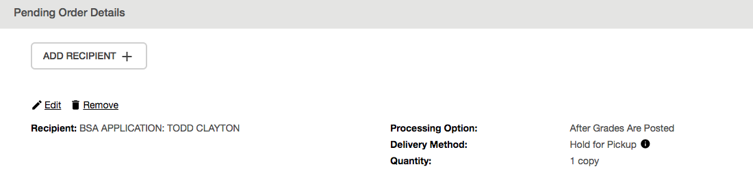
- Finally, submit a consent form to the National Student Clearinghouse via mail or provide a scanned copy in an email attachment.

After spring grades are posted, the HLS Registrar will process your request and provide a copy of your transcript to the Director of the First-Year Legal Research & Writing Program, Susannah Barton Tobin, who will be the only person to see your transcript.

